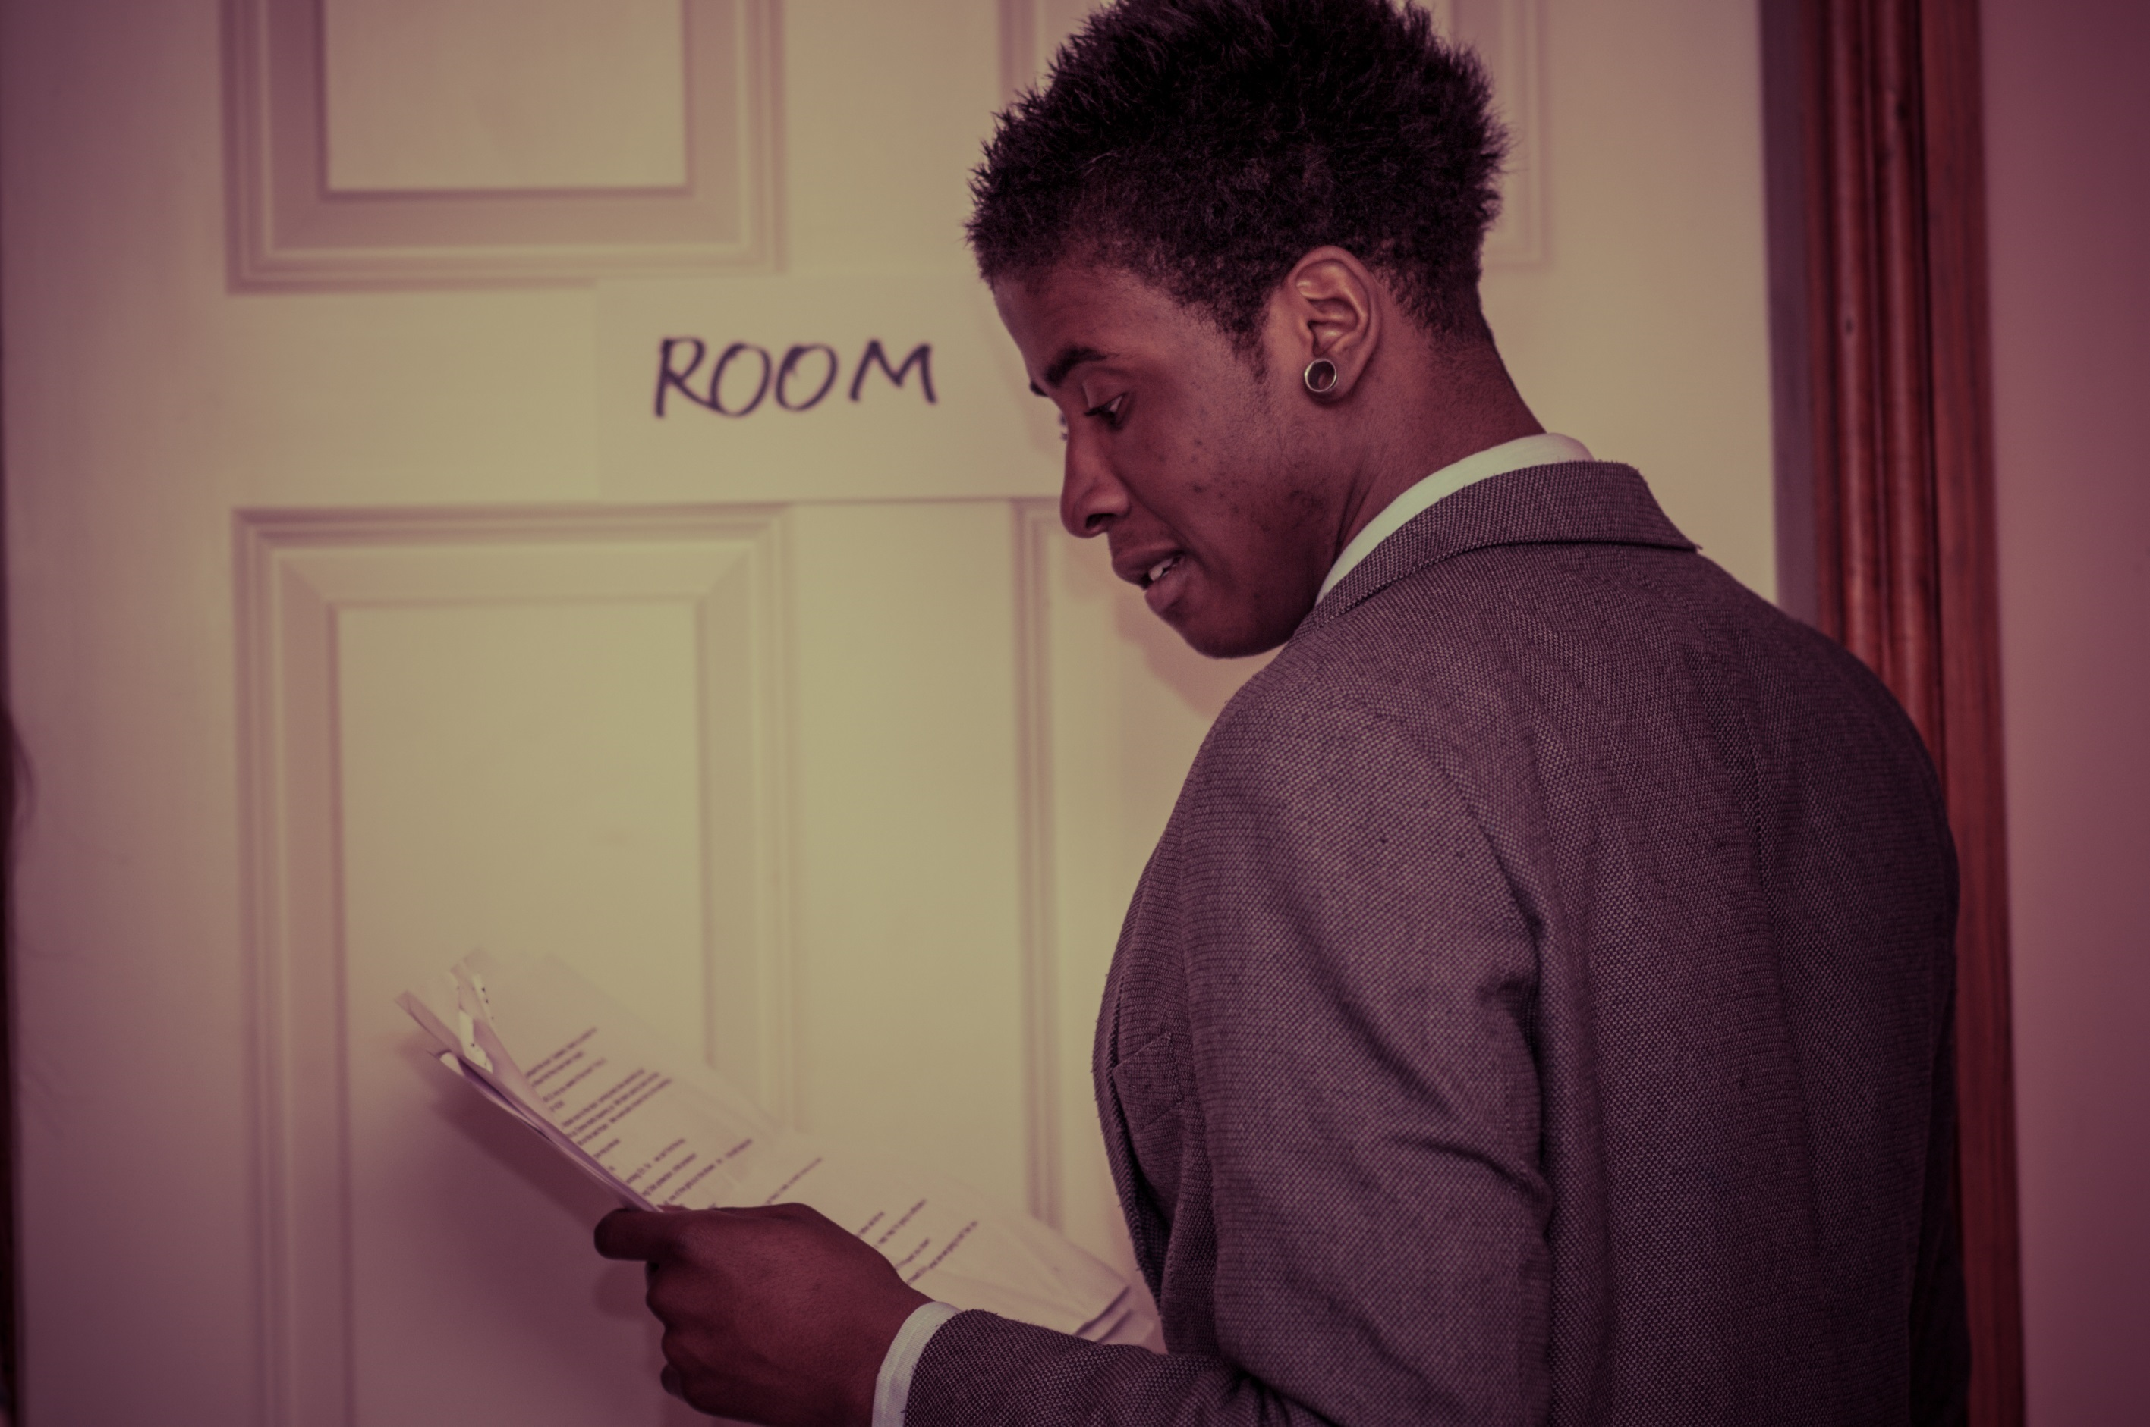
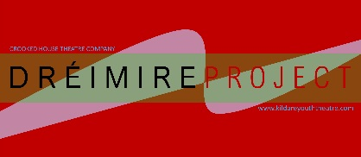
AUDITION

Dréimire Project

INTERIM REPORT

18 MARCH 2021

Presented by Graham Butler-Breen and Peter Hussey
Introduction
Crooked House Theatre Company submitted a proposal for the Dréimire Project to the Arts Council’s Young People, Children and Education Project Award in September 2020. A decision to fund the project was received on 24th November 2020.

The Dréimire Project project aimed to offer intensive support to 20 young people from low socio-economic backgrounds, from ethnic minorities, diverse and immigrant backgrounds, to audition for performance courses at third level and further education in Ireland and in the UK. We opened a partnership with The Lir Academy in Dublin to provide some of the programme.

The project, if approved, had intended to begin on 1st November 2020. After the funding decision was announced we began work on Dréimire a month later than intended.

Recruitment
Immediately we began the process of recruitment. First, we recruited a Project Administrator. Graham Butler Breen has been employed on a part-time basis to manage this project for Crooked House. Graham is well placed to understand the project as he has been accepted onto a Master’s Degree in Acting programme at RADA in London. However, due to COVID restrictions his course will not be starting until mid-2021 and so Graham has time to devote to this programme. He is also a past member of Kildare Youth Theatre and has been employed by Crooked House previously to run workshops and to direct young people in collaborative creative projects. He established his own theatre collective last year with whom he makes online work since the pandemic began.

We also contracted three Acting Tutors to work with participants on a one-to-one basis from January 2021 onwards. They are artists Peter Hussey, Rob Salmon and Georgina Kakoudaki. Peter has taken charge of 6 participants, while Rob and Georgina have 4 each. Each tutor has experience and skill in working with young people from diverse backgrounds helping them audition for third level acting degrees in Ireland, the UK and Europe. Rob Salmon was Associate Artist with the New Wolsey Theatre in Ipswich for 11 years where he directed several productions and ran the Young Company. He is an actor-trainer having successfully helped young people to find places in third-level acting colleges in the UK. Georgina Kakoudaki is a theatre director and former Education Director of the Epidaurus Festival in Greece. She teaches at the national theatre school in Athens and has prepared young people for audition to European theatre schools. Peter Hussey is Artistic Director of Crooked House in Ireland. He set up Kildare Youth Theatre and has supported young people to find places in Irish and UK acting degrees.

We set about spreading the word in order to recruit participants onto the programme. We were conscious that it was already late enough for people to prepare for drama school auditions since many colleges were already holding auditions in November.

In December we designed a flyer (Appendix I) and an information document, and sent these to:
- Youth theatres in Ireland
- Youth workers working with refugee and migrant groups (from Maynooth University’s Youth and Community Work courses)
- Community Education Officers ETBs in Leinster
- Migrant support groups and organisations.

By early January we had 14 participants enrolled on the programme.

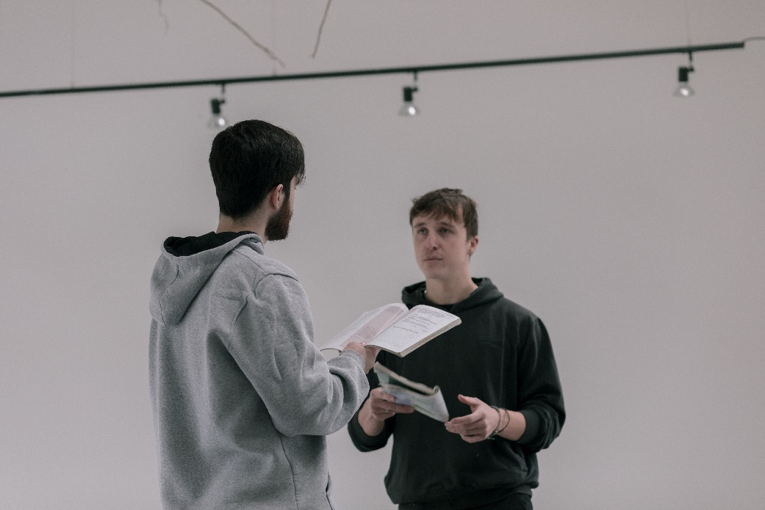
We commissioned a young film-maker, Douglas Morrison, to shoot and edit all film material associated with the project. Douglas is an associate artist with Crooked House, and is now co-facilitating drama workshops for teenagers. He has also got experience of auditioning as he did so last year. He is now studying Film-making at UCD.

Partnerships
We met with the Lir Academy staff in early January and established a calendar of activity for the remainder of the year. This includes workshops with young people on the programme.
The first Lir all-day workshop will be with those young people who have already auditioned to colleges and have received at least one recall. There are 6 of them. It is scheduled for 21st March with theatre-maker Iseult Golden.
The second Lir all-day workshop will be with those who have auditioned but are not ready yet for third level – there are 8 of those – and it will be on 3rd April.
Further workshops are planned for first time applicants and those new to the programme later in the year.
The Lir also connected us with their young graduate Ambassadors who are from ethnic minority backgrounds. We have scheduled video recorded interviews with these to occur in March and April.

We met with Secret Heart Theatre Company in London in early February. Secret Heart offer day-long workshops for young people preparing to audition for third level acting degrees. The workshops are led by Seb Harcombe, former Head of Acting at RADA and at Drama Centre, London. He is assisted by actor and RADA graduate Charlie Archer. We organised a workshop for 7 participants on 7th March – these seven had received call-backs already from other auditions this year. The workshop was extremely useful, and each participant received written feedback afterwards from Seb and Charlie. One participant evaluated it as follows:
Secret Heart Audition Workshop
“I found the workshop very useful. Seb and Charlie were not only really insightful and offered great advice, but excellent to talk to and made the entire experience enjoyable. The advice they had was of great benefit to me and helped me see my own work in a different way and improve it for the I better. This improvement was not only in my monologues, but in the interview process at the end.
Furthermore, the mock audition provides good experience, allowing me to see the process on both sides of the panel. Overall, just great stuff.”
Dréimire Participant

I found this workshop super useful and it certainly helped me as a performer - and auditionee - in a number of ways. Seb and Charlie are obviously very well-versed in their craft but their genuineness and honesty made for a relaxed and effective workshop environment. We were given an opportunity to perform both classical and contemporary monologues multiple times, each rendition catering toward a certain area that the facilitators chose. They worked with us individually, honing in on key messages, context, emphasis as well as many other components used in monologue delivery. The feedback was succinct and thought-through, and I felt my monologues improved in correlation with their suggestions. Other areas of the audition process were also discussed, things like the basic audition etiquette and common questions of interviews. Many of the points made were new to me and I’m very grateful to have had that opportunity. The workshop ended with a mock-audition, including a makeshift ‘panel’ of judges derived from the workshop participants.

We have scheduled a further workshop with them for April with the remaining 7 participants on the programme.

We would very much like to develop this relationship with Secret Heart due to the background and experience of the artists and also due to the success, relevance and usefulness of the workshops.

One-to-One Support
From December each of the acting tutors worked weekly with participants as they came on stream. Most young participants received two sessions online per week: each session was 90 minutes long.
People who were new to the area of auditioning were also given support in applying through the UCAS system, writing Personal Statements, and evaluating various programmes and courses.
In March there are still 6 young people receiving one-to-one audition support as they are receiving re-calls.
Each participant also received financial support to pay audition fees, UCAS registration, and recall fees where applicable.
Due to COVID-19 restrictions none of the support sessions happened in-person: all were, and continue to be, online via Zoom.

Shakespearean work
One of our goals was to involve young people in the production of a Shakespearean play, so that they might become familiar with acting in verse (speeches form Shakespeare and his contemporaries are required for the majority of auditions so familiarity with this way of performing would be essential). We managed to place 6 on the programme into Kildare Youth Theatre’s production of The Merchant of Venice. The 6 participants are new to auditioning and therefore experience and confidence in performing become important. The older members of the programme have experience in performing and 4 of them have auditioned before.

Rehearsals have all been on Zoom so far. However, the aim is to stage the work in July if restrictions allow.

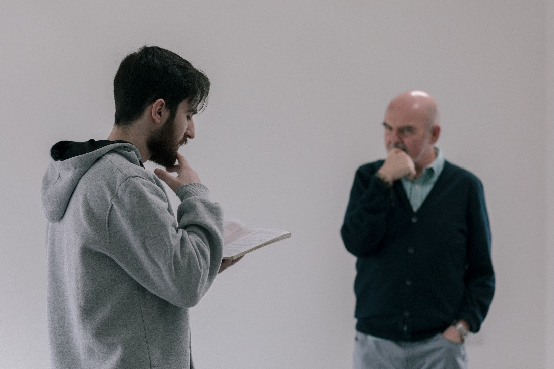
Filming
We began our filming in February. We decided to make a film around a number of classical monologues. This decision was based on feedback and need of the participants. Therefore, we have selected an equal number of speeches for performers
identifying as male and as female. There will be a film on each one: with Peter Hussey working with a young actor and member of the programme on each one. This far we have filmed a 40-minute session on Angelo’s monologue from Measure for Measure; and a 40-minute session on Portia’s speech from The Merchant of Venice.

As well as filming for the webinar sessions, we are also recording interviews with past Kildare Youth Theatre members on their experiences with the drama schools at which they gained a place. Thus far, we have recorded and edited Zoom interviews with Jerry Iwu (a recent graduate from the Royal Central School of Speech and Drama), Elliot Nolan (a current student in LAMDA) and Sarah McCormack (a recent graduate of the Bristol Old Vic Theatre School).

We have also scheduled interviews to be filmed with two graduates from The Lir in Dublin.

Website
All materials will be available for free on our newly designed website. It is being designed and created now during March. We hope to have it launched at the end of April 2021.

Challenges and Complications
COVID-19 continued to be a challenge. We have been under Level 5 restrictions for the majority of the programme to date, and for longer than we envisaged while planning the project. It meant that we have been unable to do the following planned activities:

- A young actors’ school every Saturday that focuses on movement, ensemble making and improvisation. Instead, we have had 5 day-long workshops that focused on improvisation and monologues work in groups (2 with the Lir, 1 with Secret Heart, and 2 with Crooked House).
- No travel to London or Dublin occurred for auditions and recalls. Considerable saving has been made on this, as all auditions and recalls have been online. (See Recommendation 1 below).
- No one has needed English language classes.
- We have not been able to visit youth theaters, youth projects, DEIS schools and reception centres to give talks or taster workshops in order to recruit participants.
- Most in-person filming has had to be postponed until Level 5 restrictions permit us to be in the same space.
- We have recorded Zoom interviews, but these are of variable film quality as they depended upon each person’s device having a good camera and on having good internet connectivity.

The majority of the participants come from County Kildare. We would like to focus on attracting young people nationally once COVID restrictions allow us to travel.

We paid for all the participants’ auditions fees and UCAS application fees. We needed to supply only one young person with internet and digital support.

Requests and Recommendations
In light of the above (especially with regard to the COVID-19 impacts) we would like to request the following from The Arts Council.

1. That we be permitted to extend the project into 2022, concluding in June 2022. We can use the savings made from the non-existent travel to continue to hire artists to work with young people on their monologues and audition preparation.

2. That we recruit new participants, targeting nationally with taster workshops and talks, after Level 5 restrictions end, in September 2021.

3. That we begin the Young Actors’ School in October 2021 when we have 20 participants. We may – hopefully – have some participants this year who go on to gain places at third level (or in PLCs). We can use this to (a) promote the project nationally, and also (b) replace them with new participants.

4. That participants are engaged in making Shakespeare scenes rather than in taking part in a full production: only if they live in Kildare will they be able to access one. We can use Zoom to rehearse participants in pairs in scenes.

Conclusion
The Dréimire project has had significant success so far even though we have had to cope with COVID lockdowns and travel restrictions. Of the 14 participants who came onto the programme 5 are through to final round recalls for RADA, LAMDA, and the Royal Central School of Speech and Drama. Four of these are also through to the next round in The Lir.
All 5 are older, aged 21 to 24. The younger participants have not succeeded in getting recalls: this suggests they will need extra support next year. Four of the younger ones have gained places on PLC courses in performance in Ireland and 1 in Scotland.

If we can extend the project, we will be able to begin with a full complement of young people (20) sourced nationally after restrictions hopefully end in the summer 2021.

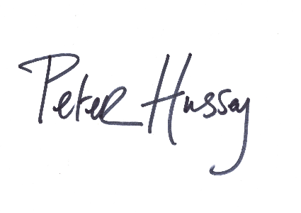

Peter Hussey Graham Butler-Breen
Project Director Project Administrator

18th March 2021
Appendix I: Recruitment Flyer
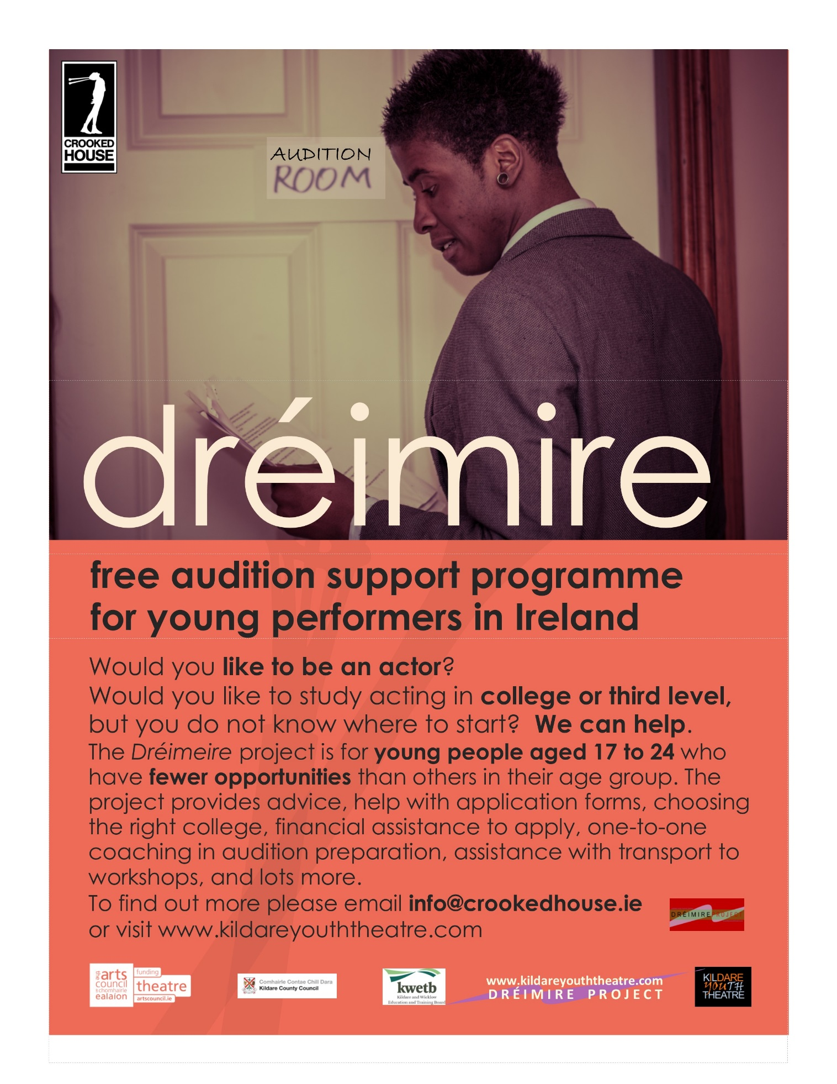

[Appendix II removed on grounds of privacy]

End of document.

