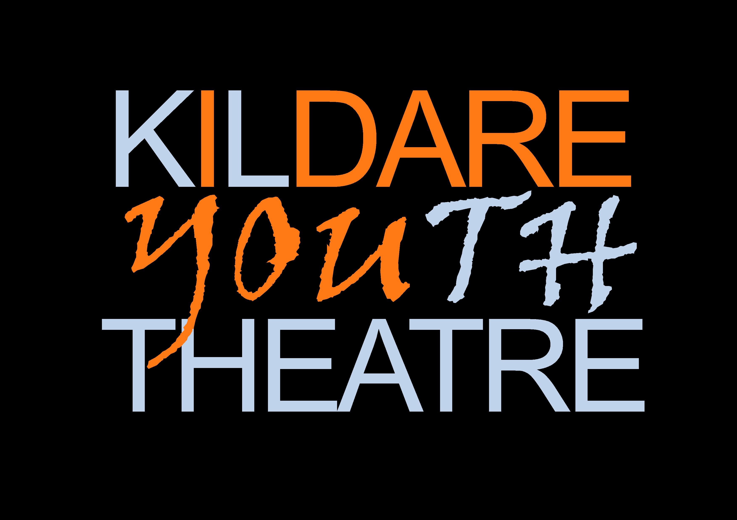
Kildare Youth Theatre New Member Form
(and Membership Renewal Form)

Section A: Young Person’s Details
ALL SECTIONS MUST BE COMPLETED
Name: | Date of birth:
Home Address:

Email: PLEASE WRITE THIS VERY CLEARLY | Mobile:
Gender:
Select (√) the programmes you wish to apply for (remember that workshops are limited to age groups). In order to find out what workshops and projects to apply for, please read the website page with workshop details here: https://www.kildareyouththeatre.com/workshops
Oberon workshop (11 – 13 year olds)
Touchstone workshop (14 to 16 year olds)
Caliban workshop (17 to 20 year olds)
Echo Ensemble (apply to audition)
OTHER (please name it or them here)

Section B: Parental / Guardian Details TO BE COMPLETED BY PARENT OR GUARDIAN for under 18s.
IF YOU ARE 18 OR OVER YOU CAN COMPLETE THIS YOURSELF WITH YOUR PARENT’S PERMISSION, OR THEY CAN COMPLETE IT – WE NEED THIS INFO FOR EMERGENCY CONTACT PURPOSES.
1 Name: | Email: PLEASE WRITE or TYPE THIS VERY CLEARLY IN CAPITAL LETTERS  Mobile:
2 Name: | Email: PLEASE WRITE THIS VERY CLEARLY IN CAPITAL LETTERS  Mobile:
I (Parent/Guardian) consent to be contacted for the purpose of verifying my identity as parent/guardian of my child. Please tick to consent:
Medical Conditions/Additional Requirements
If you do not have sufficient space to provide full details, please include an extra sheet. Any information provided will be treated as confidential and managed in line with the youth theatre’s Confidentiality Policy.
1 Does your son/daughter/ward have any additional requirements? e.g. physical disability, learning difficulties or literacy issues. If ‘Yes’, please give details. |  | Yes | No
2 Does your son/daughter/ward have any medical conditions of which we should be aware?  If ‘Yes’, please give details |  | Yes | No
3 Does your son/daughter/ward have any allergies?  If ‘Yes’, please give details |  | Yes | No
4 Is there any other information we need to be aware of that may impact on your son’s/daughter’s participation in youth theatre?  If ‘Yes’, please give details |  | Yes | No

Section C: Parental Consent TO BE COMPLETED BY PARENT OR GUARDIAN of under 18s. To be completed by the young person if 18 or over
I give consent
1 For personal data to be processed in line with the purposes detailed in the Privacy Statement at the end of this form. | Yes | No
2 Photograph/Video Footage of me or of my son/daughter to be taken during youth theatre events. | Yes | No
3 Photographs/Video Footage including me or my son/daughter to be used publicly in posters/flyers and/or newspapers for publicity purposes. | Yes | No
4 Photos/Video footage to be stored and used for archival purposes (All photos/video footage will be managed in line with the youth theatre’s Use of Images Policy). | Yes | No
5 First aid/medical assistance to be sought in the case of an emergency. | Yes | No
6 I have disclosed all relevant information with regard to any medical conditions and any additional requirements that relate to my son/daughter of which I am aware. | Yes | No
7 I have read the Information Sheet provided by the youth theatre. | Yes | No
*If you wish to discuss any matter in relation to the above, please do not hesitate to contact Peter Hussey on info@crookedhouse.ie or 087 2759420

Section D: Parent / Guardian Signature TO BE COMPLETED BY PARENT OR GUARDIAN

I have read all the above and responded to each question. I agree to the conditions implied or stated above.
Signed: | Date:

Section E: Voluntary Donation
There are no fees for your son/daughter to join the youth theatre and to take part in any of its activities. However, if you would like to make a voluntary, optional, donation please do so. We are always fundraising to run our projects. You can transfer whatever amount you wish to Crooked House Theatre Company’s bank account:
Name of Account: Crooked House Theatre Company
Name of Bank: Bank of Ireland
Address: Main Street, Newbridge, Co Kildare, W12 A003.
IBAN: IE61BOFI90126314851789.
BIC: BOFIIE2D
Please make sure to make a note online with the transfer saying ‘donation’ or ‘KYT’ so that we know what this payment into our account is for.
Crooked House is a registered charity: No 20143534 with Revenue CHY number 20229.

Section F: Members’ Consent for Photos – this is to be signed by the young person

I give my consent for photos/footage of me to be taken during youth theatre activities and for them to be used for publicity and for the youth theatre archive. | Yes | No
Signed_______________________________ Date:___________________________

Additional Information relating to Medical Conditions or Additional Requirements.

Please note if you would like to discuss any of the information relating to your son’s/daughter’s medical conditions or additional requirements with us, please contact Peter Hussey on info@crookedhouse.ie or 087 2759420. We may also contact your for clarification or more information if necessary.

PARENTAL CONSENT FOR USE OF PERSONAL DATA
Crooked House and Kildare Youth Theatre will use personal data only where consent to do so is affirmative, freely given, specific, informed and unambiguous. The below privacy statement provides information on why we gather and how we will use your son’s / daughter’s personal data. The Data Protection Contact Person at Crooked House and Kildare Youth Theatre is Peter Hussey. You can contact this person on info@crookedhouse.ie if you have a question regarding how your son’s/ daughter’s personal data will be processed.
Privacy Statement The personal data requested in this form is collected solely for the purpose of supporting your son’s/ daughter’s participation in Crooked House and Kildare Youth Theatre. Data such as contact details will be used to communicate with you and your son/ daughter in relation to your son’s /daughter’s membership of the youth theatre.
Data such as gender and age is used to ensure your son / daughter is assigned to aspects of the youth theatre activities that are age appropriate. It also helps us to make accommodation and other arrangements in the case of trips or residentials your son/ daughter may participate in during their time in membership of the youth theatre. Details of your son’s /daughter’s age and gender are also provided to funders and Youth Theatre Ireland to generate statistical information but are aggregated with all members and not directly linked to your son/ daughter personally or used to identify your son/daughter to third parties in any way. Sensitive personal data such as details of medical conditions or other personal needs are collected so that we can ensure the safety and welfare of your son / daughter whilst participating in the youth theatre. Your son’s/ daughter’s personal data will only be shared with those who need to know it, and only disclosed to a third party in the case of an emergency such as if they become ill or have an accident that requires medical attention. Images including video will be collected for the purpose of promoting and documenting the activities of Crooked House and Kildare Youth Theatre and for archival purposes. Images will be managed safely in line with our Use of Images Policy. The promotion of our productions and other events requires that on occasions images will be used in the public domain. Crooked House and Kildare Youth Theatre will retain personal data on file for the duration of that young person’s membership in the youth theatre and for 3 years after the leave. Personal data in the form of photographic images and video will be retained permanently or until such time they become obsolete for the purpose of promoting and documenting the activities of Crooked House and Kildare Youth Theatre
Your rights:
Crooked House and Kildare Youth Theatre is committed to upholding yours and your son’s /daughter’s rights as provided for by the General Data Protection Regulation (GDPR) including:
- The right to be informed about how we will use your personal data.
- The right of access to a copy of the personal data we hold and information on how we process it.
- The right to have incorrect or incomplete personal data corrected.
- The ‘right to be forgotten’ and have personal data deleted if you so request.
- The right to restrict how we process your personal data.
- The right to object to the processing of your personal data.
- The right to data portability

To be completed by Parent / Guardian
I consent to the use of the personal data provided for the purposes outlined in the above Privacy Statement.

Signed: __________________________​Date: _______________

Date received by Crooked House Theatre Company:
Email addresses are legible?
All sections are complete and signed?
All sections correct (e.g. correct age for workshops etc)?
Needs to be returned to parent/young person for completion or due to error?
Reviewed by (Name)
This section for Office Use Only

